Many users will run an MQTT broker such as [mosquitto](http://mosquitto.org/) on the same Raspberry Pi or PC that Node-RED is running on.

Once you have an MQTT input or output node in your flow, you create an MQTT Config node by clicking on the Server configuration pop-up and selecting Add an MQTT broker....

Assuming your broker is open, set the server host to localhost and leave the port set to 1883.

To connect to non-local, secured brokers, other MQTT Config node options will need to be set according to your broker’s connectivity requirements.

# **node-red-contrib-mqtt-broker**

Once you just put this node on Node-RED and hit deploy button, MQTT Broker will run on your Node-RED.

Use the MQTT Input input or MQTT Output node and an associated MQTT Config node to connect to an MQTT broker.

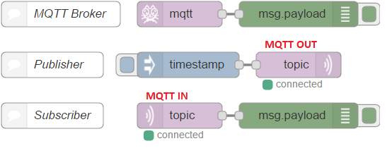

You can set "localhost" in MQTT-in and MQTT-out properties as follows.

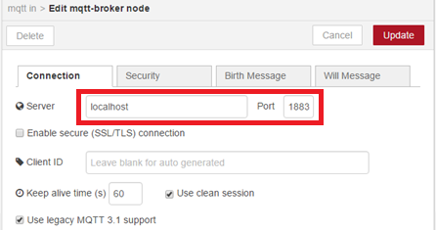

[{"id":"2c6873d2.992abc",

"type":"mqtt out",

"z":"eda2a949.74ea98",

"name":"",

"topic":"sensors/livingroom/temp",

"qos":"","retain":"",

"broker":"407a01e4.6b637","x":330,"y":80,"wires":[]},

{"id":"d9beed59.94155",

"type":"inject",

"z":"eda2a949.74ea98",

"name":"",

"topic":"",

"payload":"22",

"payloadType":"num",

"repeat":"","crontab":"",

"once":false,"x":150,"y":80,

"wires":[["2c6873d2.992abc"]]},

{"id":"be80048.8f232f8",

"type":"mqtt in",

"z":"eda2a949.74ea98",

"name":"",

"topic":"sensors/livingroom/temp",

"qos":"2",

"broker":"407a01e4.6b637",

"x":170,"y":160,

"wires":[["8640b8ff.f82ff8"]]},

{"id":"8640b8ff.f82ff8",

"type":"debug",

"z":"eda2a949.74ea98",

"name":"","active":true,

"console":"false",

"complete":"false",

"x":370,"y":160,"wires":[]},

{"id":"407a01e4.6b637",

"type":"mqtt-broker",

"z":"",

"broker":"localhost",

"port":"1883",

"clientid":"",

"usetls":false,

"compatmode":true,

"keepalive":"60",

"cleansession":true,

"willTopic":"",

"willQos":"0",

"willPayload":"",

"birthTopic":"",

"birthQos":"0",

"birthPayload":""}]